Use the ap database on our server DBA120.abtech.edu to execute the following SELECT statements.

*Screen clip your query and results below each instruction**. Remember:** DO NOT screen print all if results set is large … just the first few and last few rows including the row count.

**(Q1 – Q8 - 9 pts ea).**

1. Write a SELECT statement that returns these columns for each vendor in the Invoices table:

|  |  |
| --- | --- |
| Column Name | Contains … |
| vendor_id | vendor_id from the invoices table |
| Invoice Total | Sum of the invoice_total columns in the invoices table for that vendor |

This should return 34 rows.

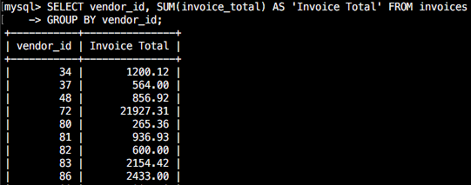

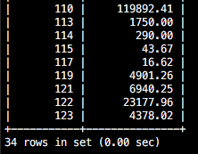

2. Using the SELECT statement from Q1, replace the vendor_id with the vendor_name from the vendors table.

|  |  |
| --- | --- |
| Column Name | Contains … |
| vendor_name | vendor_name from the vendors table |
| Invoice Total | Sum of the invoice_total columns in the invoices table for that vendor |

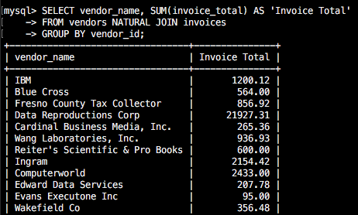

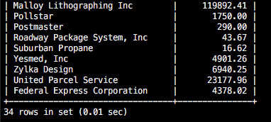

3. Write a SELECT statement that returns these columns for each vendor in the Invoices table:

|  |  |
| --- | --- |
| Column Name | Contains … |
| vendor_name | vendor_name from the vendors table |
| payment_total | Sum of the payment_total columns in the invoices table for that vendor |

This should return 34 rows.

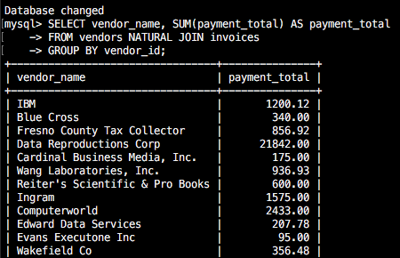

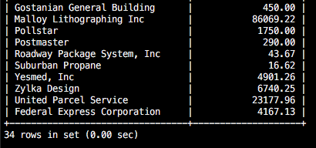

4. Write a SELECT statement that returns these columns for each vendor in the Invoices table:

|  |  |
| --- | --- |
| Column Name | Contains … |
| vendor_name | vendor_name from the vendors table |
| number invoices | count of the invoices in the invoices tables for each vendor |
| invoice_total | sum of the invoice_total column in the invoices tables for each vendor |

This should return 34 rows.

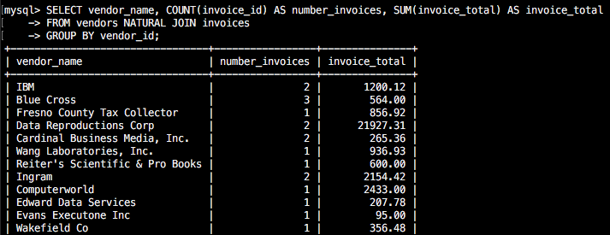

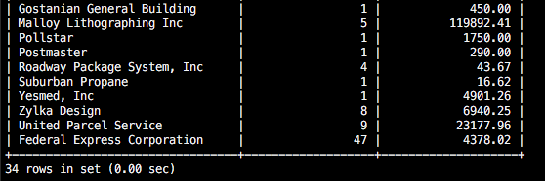

5. Each invoice_line_item contains an account_number because each line can be billed to a different account number (i.e. postage, utilities, etc.)

Write a SELECT statement that returns these columns for each account_number in the invoice line items table where the count of items is greater than 1. Group the result set by account description and sort the results in descending sequence by the sum of the line item amounts.

|  |  |
| --- | --- |
| Column Name | Contains … |
| account_description | account_description column from the general ledger accounts table |
| count_of_items | count of the items in the invoice line items tables that have the same account number |
| line_item_sum | sum of the line_item_amount for items with the same account number |

This should return 10 rows.

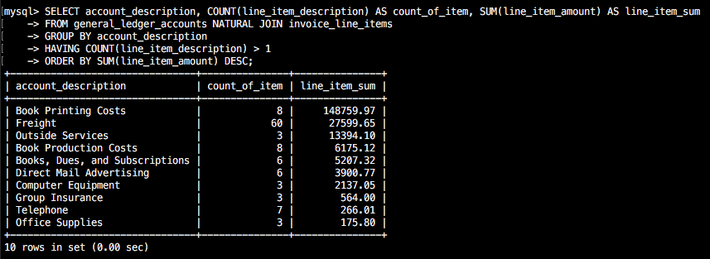

6. Modify the SELECT in Q5 so it returns only the invoices dated in the 2nd quarter of 2014 (April 1, 2014 to June 30, 2014). This should still return 10 rows, only with some different line item counts for each vendor. *Hint: Join the invoices table so that you can code a search condition based on the invoice_date.*

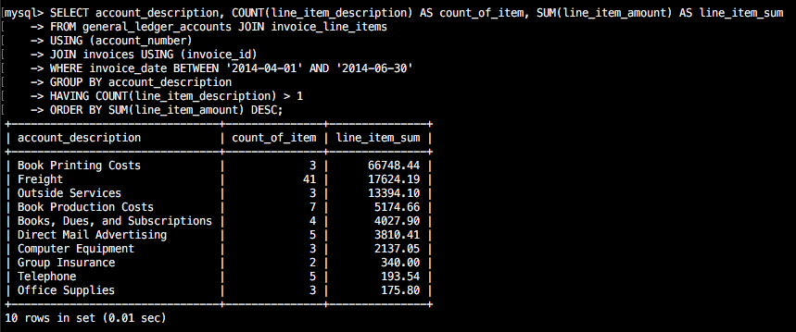

7. Write a SELECT statement that answers this question? What is the total amount invoiced for each general ledger account number? Return these columns and use the WITH ROLLUP operator:

|  |  |
| --- | --- |
| Column Name | Contains … |
| account_number | Account_number from the invoice line items table |
| line_item_sum | sum of the line_item_amount for items with the same account number |

This should return 22 rows.

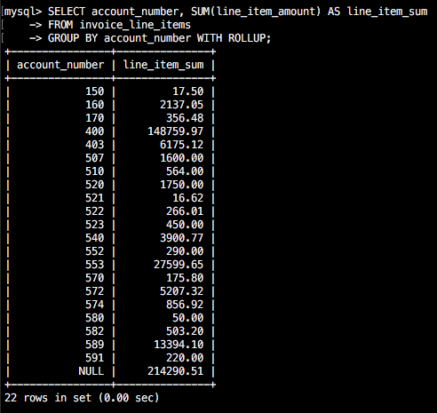

8. Write a SELECT statement that answers this question: Which vendors are being paid from more than one account? Return the following columns:

|  |  |
| --- | --- |
| Column Name | Contains … |
| vendor_name | vendor_name from the vendors table |
| number_of_gl_accounts | Count of disctinct general ledger accounts that apply to that vendors’ invoices |

This should return 2 rows.

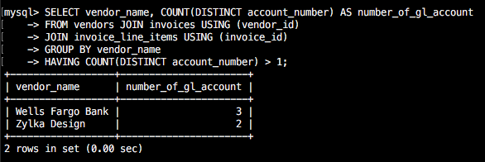

**For the following exercises, use the Recipes database. There is an ERD and sample queries posted in Moodle to assist you in understanding.**

**\*Screen clip your query and results below**

**(Q9 – Q12 - 7 pts ea)**

9.How many ingredients are measured by the cup?

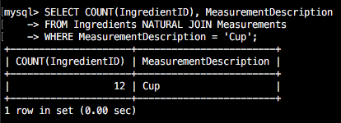

10. Count the number of main course recipes.

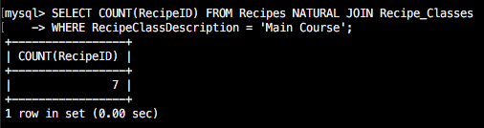

11. Which recipe requires the most cloves of garlic? (assume Garlic is always used in cloves)

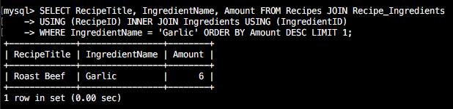

12. Calculate the total number of teaspoons of salt in all recipes.

